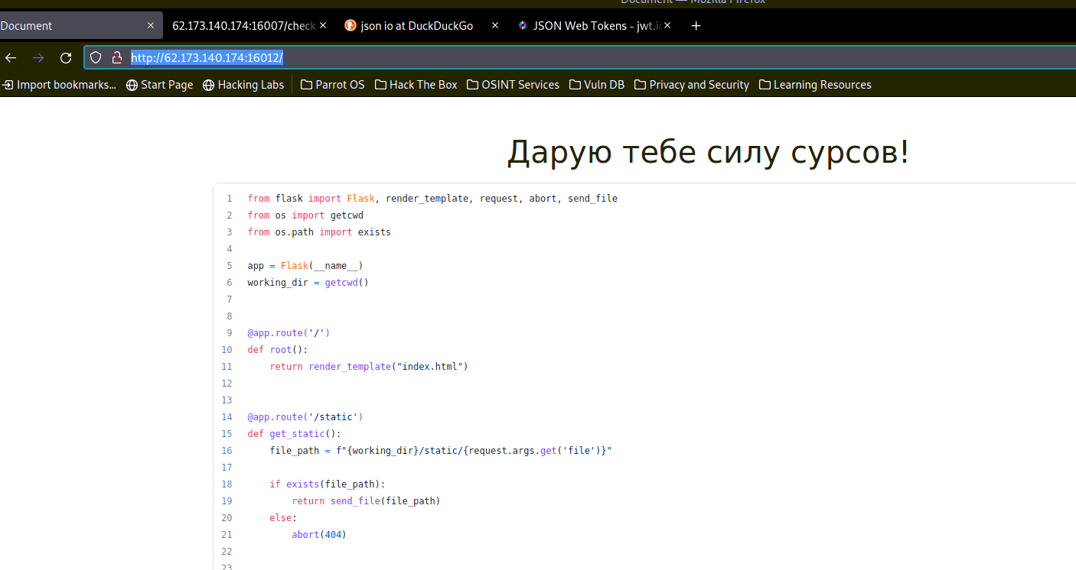

<https://book.hacktricks.xyz/pentesting-web/file-inclusion#basic-lfi-and-bypasses>

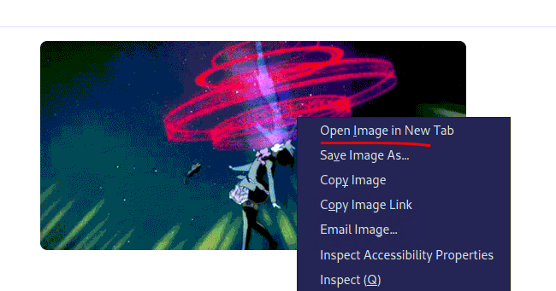

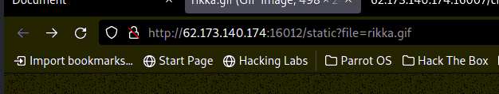

https://github.com/carlospolop/Auto_Wordlists/blob/main/wordlists/file_inclusion_linux.txt

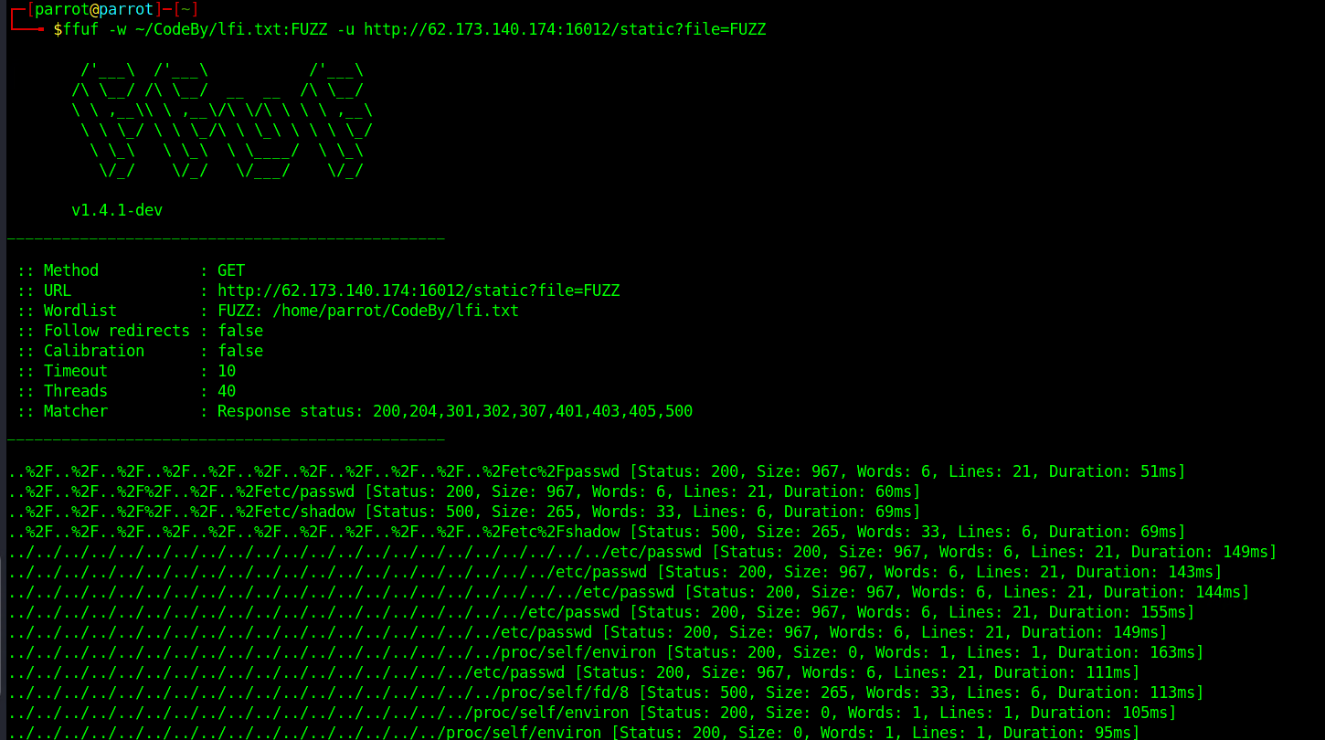

ffuf -w ~/CodeBy/lfi.txt:FUZZ -u <http://62.173.140.174:16012/static?file=FUZZ>

